High-Low Clustering Report
Observed General G: | 0.001085
z-score: | 12.265787
p-value: | 0.000000
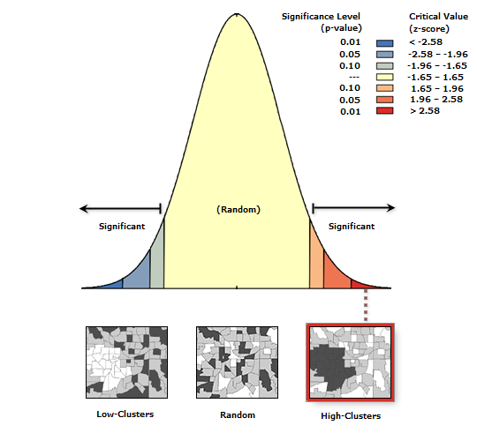
Given the z-score of 12.27, there is a less than 1% likelihood that this high-clustered pattern could be the result of random chance.
General G Summary
Observed General G: | 0.001085
Expected General G: | 0.000738
Variance: | 0.000000
z-score: | 12.265787
p-value: | 0.000000

Dataset Information
Input Feature Class: | HavatEden_B
Input Field: | ALEKETLEVE
Conceptualization: | INVERSE_DISTANCE
Distance Method: | EUCLIDEAN
Row Standardization: | False
Distance Threshold.: | 20.0
Weights Matrix File: | None

בית הלל 3 מזרח(סף מרחק:40 מטר)

High-Low Clustering Report
Observed General G: | 0.000064
z-score: | 7.017278
p-value: | 0.000000

Given the z-score of 7.02, there is a less than 1% likelihood that this high-clustered pattern could be the result of random chance.
General G Summary
Observed General G: | 0.000064
Expected General G: | 0.000060
Variance: | 0.000000
z-score: | 7.017278
p-value: | 0.000000

Dataset Information
Input Feature Class: | BHilel3East
Input Field: | ALEKETLVL
Conceptualization: | INVERSE_DISTANCE
Distance Method: | EUCLIDEAN
Row Standardization: | False
Distance Threshold.: | 40.0
Weights Matrix File: | None

בית הלל 3 מזרח(סף מרחק:80 מטר)

High-Low Clustering Report
Observed General G: | 0.000084
z-score: | 7.819869
p-value: | 0.000000

Given the z-score of 7.82, there is a less than 1% likelihood that this high-clustered pattern could be the result of random chance.
General G Summary
Observed General G: | 0.000084
Expected General G: | 0.000079
Variance: | 0.000000
z-score: | 7.819869
p-value: | 0.000000

Dataset Information
Input Feature Class: | BHilel3East
Input Field: | ALEKETLVL
Conceptualization: | INVERSE_DISTANCE
Distance Method: | EUCLIDEAN
Row Standardization: | False
Distance Threshold.: | 80.0
Weights Matrix File: | None

יפעת חלקה ו'

High-Low Clustering Report
Observed General G: | 0.000095
z-score: | 25.157884
p-value: | 0.000000

Given the z-score of 25.16, there is a less than 1% likelihood that this high-clustered pattern could be the result of random chance.
General G Summary
Observed General G: | 0.000095
Expected General G: | 0.000079
Variance: | 0.000000
z-score: | 25.157884
p-value: | 0.000000

Dataset Information
Input Feature Class: | yifat_Vav
Input Field: | ALEKETLV
Conceptualization: | INVERSE_DISTANCE
Distance Method: | EUCLIDEAN
Row Standardization: | False
Distance Threshold.: | 80.0
Weights Matrix File: | None

בית הלל 3 מזרח (MORAN I סף מרחק:40)

Spatial Autocorrelation Report
Moran's Index: | 0.419646
z-score: | 16.194242
p-value: | 0.000000
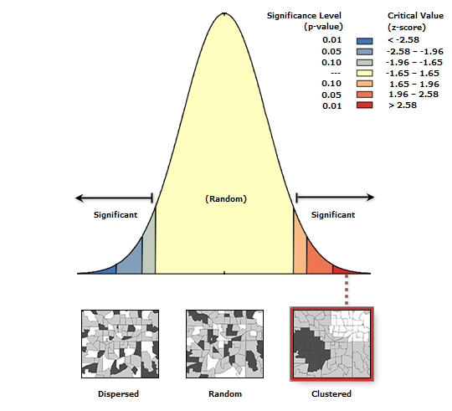
Given the z-score of 16.19, there is a less than 1% likelihood that this clustered pattern could be the result of random chance.
Global Moran's I Summary
Moran's Index: | 0.419646
Expected Index: | -0.001449
Variance: | 0.000676
z-score: | 16.194242
p-value: | 0.000000

Dataset Information
Input Feature Class: | BHilel3East
Input Field: | ALEKETLVL
Conceptualization: | INVERSE_DISTANCE
Distance Method: | EUCLIDEAN
Row Standardization: | False
Distance Threshold.: | 40.0
Weights Matrix File: | None

בית הלל 3 מזרח (MORAN I סף מרחק:120)

Spatial Autocorrelation Report
Moran's Index: | 0.297599
z-score: | 16.842255
p-value: | 0.000000

Given the z-score of 16.84, there is a less than 1% likelihood that this clustered pattern could be the result of random chance.
Global Moran's I Summary
Moran's Index: | 0.297599
Expected Index: | -0.001449
Variance: | 0.000315
z-score: | 16.842255
p-value: | 0.000000

Dataset Information
Input Feature Class: | BHilel3East
Input Field: | ALEKETLVL
Conceptualization: | INVERSE_DISTANCE
Distance Method: | EUCLIDEAN
Row Standardization: | False
Distance Threshold.: | 120.0
Weights Matrix File: | None

